Soybean Sort

Number each picture in order of the plant’s life cycle. Then, label each picture using the word bank below.

Seed Seedling Germination Flowering

Growing Plant Mature Pod Green Pod

**4**

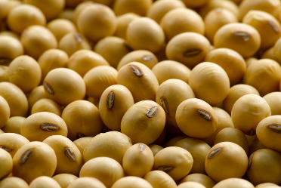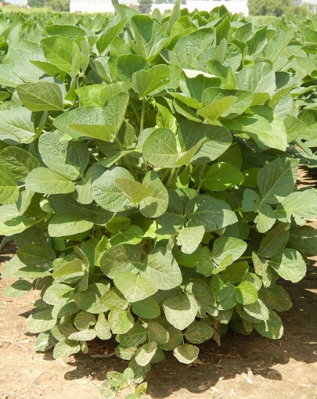

**1**

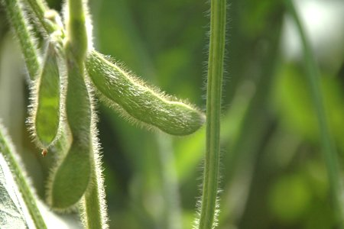[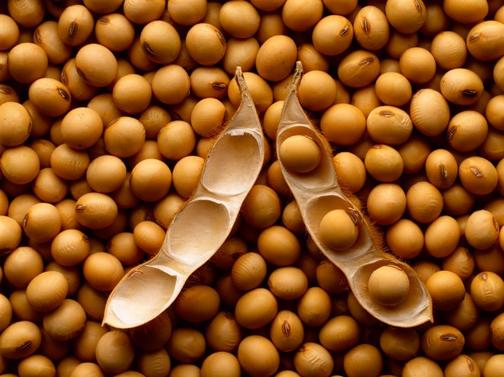](http://www.google.com/url?sa=i&rct=j&q=&esrc=s&source=images&cd=&cad=rja&uact=8&ved=0ahUKEwiDs8mHgp3RAhUGQiYKHfRHA2AQjRwIBw&url=http://www.arvglobaltrading.com/product/mature-soybean/&bvm=bv.142059868,d.eWE&psig=AFQjCNGIFSaXSm20G3eI6LfRSa60-_y3nQ&ust=1483225048555680)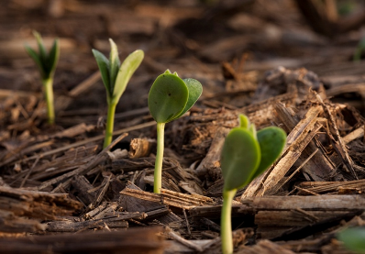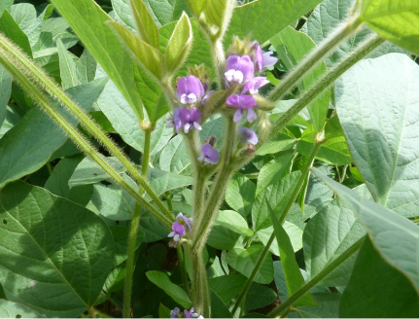

**Seedling**

**Green Pod**

**Mature Pod**

**Growing Plant**

**Seed**

**Germination**

**Flowering**

**5**

**6**

**7**

**3**

**2**

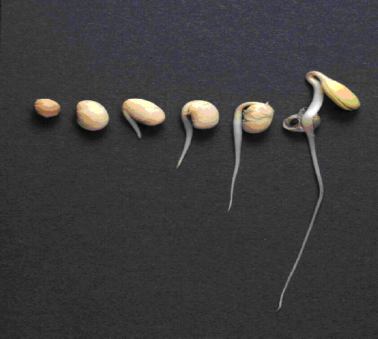



Using what you learned, write at least three complete sentences about the soybean lifecycle.

* Farmers plant seeds in the spring using a planter.
* All plants need water and light to grow.
* Leaves absorb sunlight and roots gather water and nutrients.
* Soybean flowers are purple or white and about the size of your pinky fingernail.
* The pods are the fruit of the soybean plant.

* Soybean pods get larger as the seeds inside them grow.
* Soybean seeds are also called beans.
* When seeds are dry and hard, farmers use a combine to harvest the field.